C PROGRAMMING TO FIND SUM OF N NUMBERS USING ANY LOOP

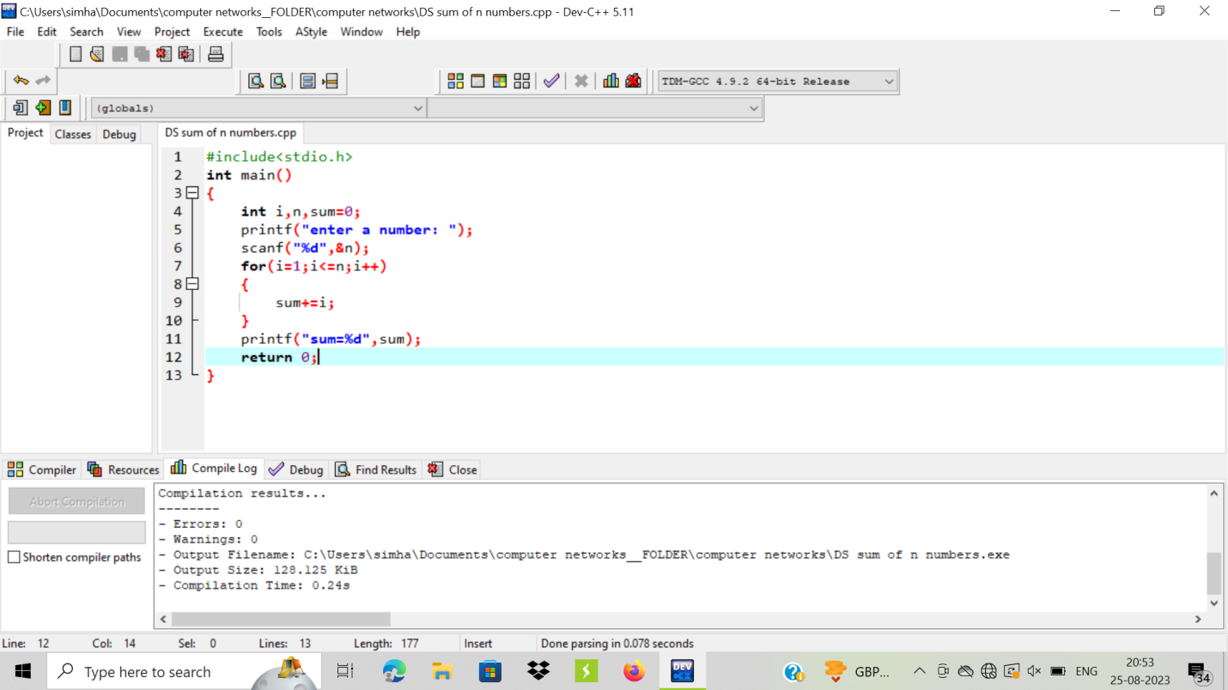

OUTPUT:

